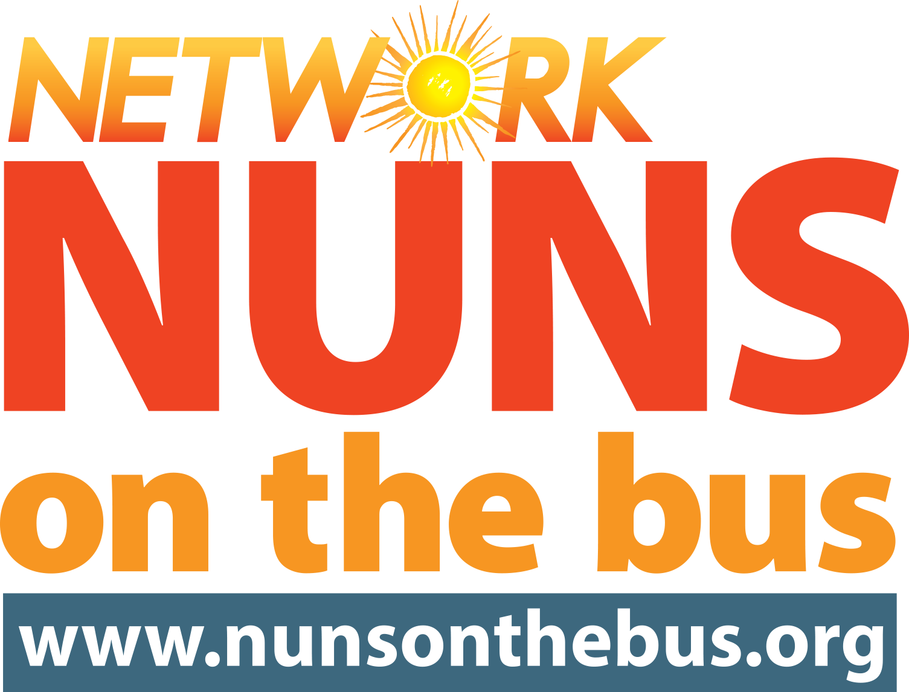

FOR IMMEDIATE RELEASE: Tuesday, September 11 2018
CONTACT: Lee Morrow | lmorrow@networklobby.org | 202-601-7871

ICYMI: As GOP Introduces Tax Heist 2.0, Nuns on the Bus Hit the Road Again
“The Republican Tax Law is already rigging the system, and we won’t let them do it again with Tax Heist 2.0,” said Sister Simone Campbell

WASHINGTON, D.C. — As the Republicans in the House introduce their new Tax Heist 2.0 to further rig the system for the wealthy and major corporations, NETWORK Lobby for Catholic Social Justice reaffirms its commitment that Nuns on the Bus are hitting the road this fall, leveraging the midterm elections to expose the lies and tell the truth about the harmful effects of the 2017 tax vote—and to hold congressional Republicans accountable for voting in favor of this disastrous tax law.

“The Republican tax law is already rigging the system, and we won’t let them do it again with Tax Heist 2.0. Last year, Nuns on the Bus stayed in Washington to keep relentless congressional attacks on the common good at bay, but this year we’re going on the road to hold members accountable for their votes,” said Sister Simone Campbell, SSS, Executive Director of NETWORK Lobby for Catholic Social Justice and Leader of Nuns on the Bus.

The Nuns on the Bus “On the Road to Mar-a-Lago” tour will include 54 events in 21 states over the course of 27 days. The tour will launch in Los Angeles with a rally and end at Mar-a-Lago in Florida with a “Fiesta for the Common Good,” traveling to congressional districts where the incumbent chose to support the deceitfully named the “Tax Cuts and Jobs Act of 2017”.

The month-long Nuns on the Bus tour, which will run from October 8 to November 2, is the sixth time the Sisters have gone on the road, beginning the tours in 2012 to protest the budget proposed by now-Speaker Paul Ryan. Organized by NETWORK Lobby for Catholic Social Justice and led by Sister Simone Campbell, SSS, prior Nuns on the Bus tours have visited 32 states to talk about economic inequality, elections, immigration, and other key issues facing the nation.

Nuns on the Bus 2018 Specifics:

Route: California - Nevada - Arizona - Colorado - Nebraska - Iowa - Missouri - Illinois - Indiana - Michigan - Ohio - Pennsylvania - New York - New Jersey - Delaware - Washington, D.C. - Virginia - North Carolina - South Carolina - Georgia - Florida

Congressional Districts: On the way to Mar-a-Lago, the Nuns on the Bus will make a focused effort to visit the congressional districts of elected officials who voted in favor of the tax law, despite the harmful effects it would have on their district, including: AZ-02; CA-45; CO-06; FL-26; IA-01; IL-06; IL-12; MI-11; NE-02; NV-03; NY-22; PA-08; PA-12; and VA-10.

Nuns: Thirty Catholic Sisters from across the country will travel on the bus. They will carry what they learn from voters across the country to President Trump’s resort at Mar-a-Lago—the pinnacle of economic inequality and hoarding of wealth. The Sisters are from:
- California (Los Angeles)
- District of Columbia
- Illinois (Chicago)
- Iowa (Clinton, Sioux City)
- Kentucky (Villa Hills)
- Maryland (Baltimore, Bladensburg)
- Michigan (Detroit, Kalamazoo)
- Minnesota (Richfield)
- Missouri (Kansas City)
- New York (Jamaica Estates, Rochester, Schenectady, Tarrytown)
- Pennsylvania (Philadelphia, Scranton)
- Wisconsin (Fon du Lac, Kenosha, Middleton, Milwaukee, St. Francis)

More information (including full route) is available on the just-announced website: www.nunsonthebus.org

To set up pre-bus interviews with Sister Simone Campbell or any of the Nuns on the Bus—or if you are interested in joining us at a stop or riding along—please contact Lee Morrow at lmorrow@networklobby.org or 202-601-7871.

Video, photos, graphics and other media support is available at www.nunsonthebus.org/media. More collateral will be added as the trip approaches.

###

Nuns on the Bus is a campaign of NETWORK: advocates for justice inspired by Catholic Sisters who educate, organize, and lobby for economic and social transformation. NETWORK has a 46-year track record of lobbying for critical federal programs that support those at the margins and prioritize the common good. www.networklobby.org

