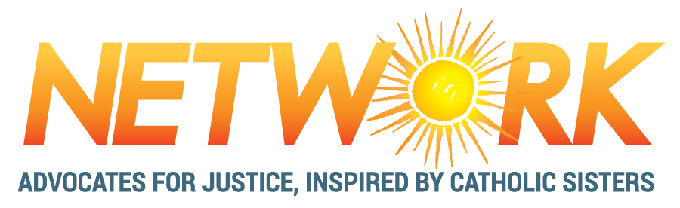

ASSOCIATE PROGRAM APPLICATION
Please type your responses or print clearly.
Due January 31, 2020

SECTION A: Background
Legal Name (First Last):
Preferred Name:
Gender Pronouns:
Address:
City, State and Zip Code:
Phone:
Email:

 | School Name | City | State | Year Graduated
High School
College (if applicable)
Other (if applicable)

How did you hear about the Associate Program/NETWORK? Mark all that apply and explain where necessary.
‘X’ | Mode | If possible, provide details.
 | Participation in NETWORK program
 | Staff/Board Member
 | Former Associate
 | NETWORK Member
 | Professor/Teacher
 | Campus Ministry Department
 | Nuns on the Bus Tour
 | Conference
 | Presentation hosted by NETWORK Staff
 | Internet/Social Media/Job Board
 | Family/Friends
 | Other:
SECTION B: Position Rankings and Short Answer Question

Available Positions
The Communications Associate creates, edits, and disseminates media to effectively communicate NETWORK’s message to the press, our members, and our activists. By assisting with media events, email marketing, and NETWORK’s social media presence, the Communications Associate will activate and engage NETWORK’s membership and the general public.
The Government Relations Associate takes on specific federal-level issues, learns about them in depth, conducts research, and creates materials for NETWORK's lobby work. In addition, this Associate attends and conducts lobby visits on the Hill and participates in coalition meetings.
The Grassroots Mobilization Associate cultivates relationships with individuals, communities, and organizations across the country to mobilize our network for political action. This Associate develops workshops and educational materials to help the public understand federal policies, the intersection of faith and politics, and effective lobby strategies.

Directions: Please answer the following questions.

1a. Which positions are you willing to accept?
Check all that apply.

____ Communications Associate

____ Government Relations Associate

____ Grassroots Mobilization Associate
1b. Please rank your preferences
(1, 2, and 3)

____ Communications Associate

____ Government Relations Associate

____ Grassroots Mobilization Associate

2. Please explain the thinking behind your choices (Less than 150 words).

SECTION C: Long Answer Questions
Directions: Please respond to the following questions. Take note of the recommended length for each question – but don't stress over it.

- How does becoming a NETWORK Associate fit as the next step for you? (250-400 words)

- What skills, gifts, and talents would you bring to this experience? In your answer, please include any personal, volunteer, or work experience connected to NETWORK’s Mend the Gap Issues (Healthcare, Housing, Immigration, Livable Income, Taxes, Voting & Democracy, and Family-Friendly Workplaces). (400-650 words)

- Describe your passion to do social justice, racial justice, and economic justice. Tell us how your life experiences, as well as your involvement in service, spiritual and/or advocacy/political activities, motivated you to work for justice of all kinds, specifically in a faith context (if applicable). (400-650 words)

SECTION D: Skills
Directions: Please indicate which skills and experience you can contribute and at what level:

Excellent | Good | Fair | Need to Learn
Writing and Research Skills:
 |  |  |  |  | Authoring clear and compelling reports, articles, or informational pieces for specific audiences (i.e. congressional staffers, student groups, coalition partners, etc.)
 |  |  |  |  | Taking and transmitting detailed meeting notes
 |  |  |  |  | Researching, analyzing and synthesizing facts, figures, and policy analyses
Interpersonal Communication Skills:
 |  |  |  |  | Relating to general public, grassroots groups, or professionals—on the phone and in person
 |  |  |  |  | Presenting information and positions to people who may or may not be like-minded
 |  |  |  |  | Public speaking
 |  |  |  |  | Foreign language skills (please indicate which language and highlight your proficiency level):
 |  |  |  |  | Language: |  | Level: Beginner Intermediate Fluent
 |  |  |  |  | Language: |  | Level: Beginner Intermediate Fluent

Computer Skills (please list the programs you have used where applicable):
 |  |  |  |  | Microsoft Word (or similar)
 |  |  |  |  | Microsoft PowerPoint (or similar)
 |  |  |  |  | Microsoft Excel (or similar)
 |  |  |  |  | Graphic & Design Software
 |  |  |  |  | Database
 |  |  |  |  | Web Design/Site Maintenance
 |  |  |  |  | Social Media Campaigns
 |  |  |  |  | Developing online education (webinars, etc.)
 |  |  |  |  | HTML/CSS

Directions: Please indicate if you have had experience in any of the following areas. On the right, indicate briefly where/when you had this experience (we will pick-up the details in your essays or on resume).
Example: Tax Justice – "Volunteered at Citizens for Tax Justice."
‘X’ |  | Experience
 | Tax Justice
 | Living Wages
 | Family-Friendly Workplaces
 | Access to Democracy
 | Access to Healthcare
 | Access to Citizenship
 | Access to Housing
 | Working with elected officials in Washington D.C.
 | Working with elected officials on the state or local level
 | Working with an advocacy or lobby organization
 | Working in an office setting
 | Living/working/volunteering in multi-ethnic or cross-cultural settings
Participating in or leading activities aimed at addressing
racism, sexism, or other forms of oppression
 | Catholic Social Justice

Do you have other skills we should know about? Please list:

SECTION E: References and Signature
Directions: List two professional references, at least one from work or volunteer activities:

Work/Volunteer Reference | Additional Reference
Name: | Name:
Relationship: | Relationship:
Phone: | Phone:
Email: | Email:

I understand that the Associate Program is from August 24, 2020 through July 30, 2021, and compensated by a learning experience, a $15,000 stipend, housing stipend, health care benefit, and a transportation benefit.

Details about the Associate Program can be found at http://www.networklobby.org/associates.

Signature: _________________________________________ Date of Application: _____________

Please email this completed application, along with your resume in the same email to:
associateprogram@networklobby.org with the subject line: “Application: Last name, First name”

Application is due January 31, 2020
Please email any questions or concerns to the email address above.
No phone calls please.

About NETWORK: A national network of social justice advocates, NETWORK educates, organizes and lobbies for economic and social transformation. Founded in 1971 by Catholic sisters in the progressive spirit of Vatican II, NETWORK works to shape federal policies to be consistent with our values. We work to “Mend the Gaps” in income and wealth disparity and work to create a society and economy of inclusion.

While rooted in Catholic Social Justice, NETWORK is open to all who share our passion for justice. Staff and members are people from a variety of religious and nonreligious backgrounds. As an organization and workplace, NETWORK values work-life balance and strives to be a supportive workplace environment where staff embrace the “Sister-Spirit” of our founders by rooting our understanding in encounter, not ideology; prioritizing the well-being of others; seeing everyone as people first, not just roles; and using humor and being feisty in order to be bold and willing to do the unpopular. We value women’s leadership, welcome and affirm the LGBTQ+ community, accept and appreciate people from religious as well as secular backgrounds, and engage in ongoing work to be a multicultural, anti-racist organization.

